You should take reasonable measures to prevent unauthorised access to confidential information. A clear desk and clear screen policy is one way to achieve this. The exact requirements of a clear desk and clear screen policy may vary from business to business, but this template policy contains example minimum requirements.

Clear desk and clear screen policy

Lilac highlighted text is used to prompts users to choose one of the wording options, as appropriate.

Red highlighted text is an ‘optional’ tag. Users can choose whether to include the wording or delete it.

Green highlighted text is an ‘insert’ tag prompting users to insert their own information (sometimes we may suggest some options to be included).

This template is produced in partnership with Lexis®PSL Practice Compliance.

Lexis®PSL Practice Compliance is an online service designed to make risk and compliance easier to manage, whatever the size of your firm. It comes with everything you need to get your compliance house in order and keep it that way, including an unbeatable range of practical guidance, templates, flowcharts, checklists and other time-saving tools.

See more at https://www.lexisnexis.com/uk/lexispsl/practicecompliance/home.

Clear desk and clear screen policy

Responsibility

1.1 [Insert [name OR job title] eg, The Risk manager] is responsible for this policy.
1.2 They are responsible for communicating the contents of this policy to all staff, ensuring it is complied with, keeping the policy under review and arranging any amendments or updates to the policy.

Purpose and application

2.1 If you are going to be away from your desk for an extended period of time, you should ensure you have taken reasonable measures to prevent unauthorised access to confidential information.
2.2 This policy sets out the measures you are expected to take as a minimum.
2.3 This policy applies to all staff.

Requirements—do’s

3.1 Lock your computer (ctrl-alt-delete) when you are away from your desk for anything more than a couple of minutes.
3.2 Protect screensavers with a password.
3.3 Shut your computer down completely when leaving the office for the day.
3.4 Dispose of any confidential information in designated confidential waste facilities.
3.5 Store confidential papers out of sight, preferably in locked cabinets, overnight or if you will be out of the office for any significant period.
3.6 Keep offices as uncluttered as possible—desks should be clear of unnecessary items.

Requirements—do not’s

4.1 Leave papers on printers overnight.
4.2 Leave phones, tablets, removable media or valuable personal belongings unattended for any significant length of time.

Reporting breaches

5.1 All members of staff have an obligation to report actual or potential data protection compliance failures. This allows us to:
5.1.1 investigate the failure and take remedial steps if necessary
5.1.2 maintain a register of compliance failures
5.1.3 notify the SRA of any compliance failures that are material either in their own right or as part of a pattern of failures
5.1.4 please refer to our Compliance failure policy for our reporting procedure

Training

6.1 All staff will receive training and/or be made aware of this policy. New joiners will receive training or information as part of the induction process and further training will be provided where necessary, including where there is a substantial change in our policy or procedures.
6.2 [The Risk manager] will continually monitor training needs but if you feel that you need further training on any aspect of our clear desk and clear screen policy or procedures, please contact them.

Failure to comply

7.1 Failure to comply with any requirement of this policy may lead to disciplinary action under our procedures.

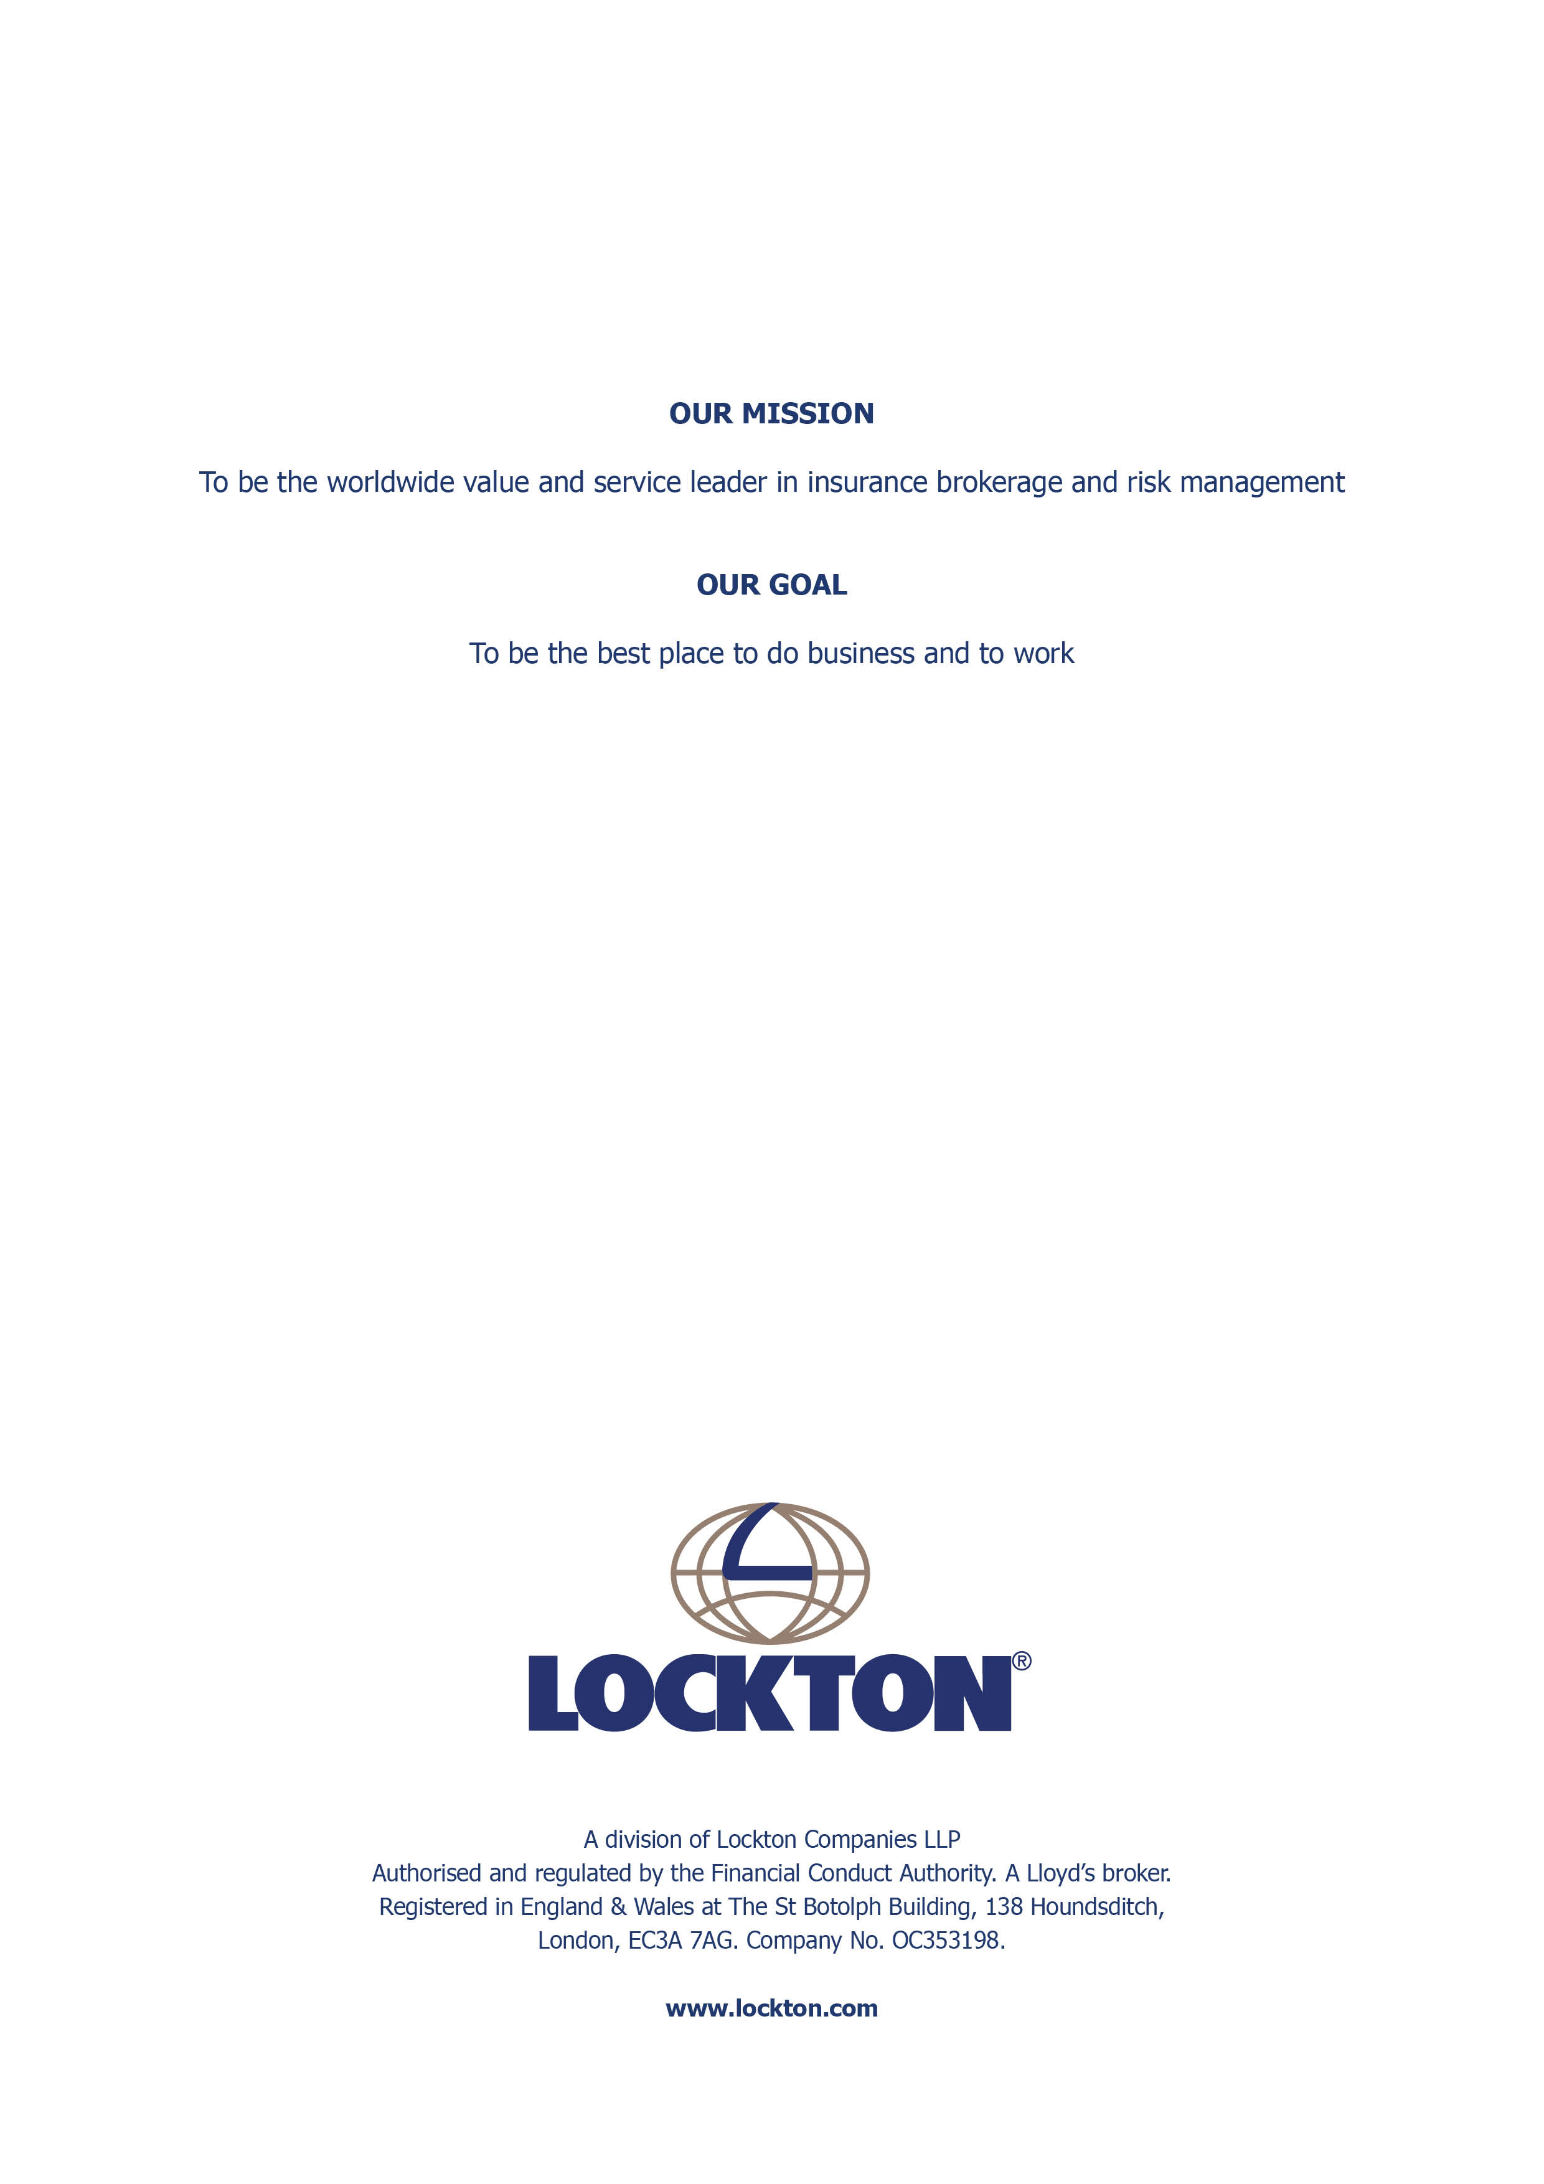

1 Clear desk and clear screen policy You should take reasonable measures to prevent unauthorised access to confidential information. A clear desk and clear screen policy is one way to achieve this. The exact requirements of a clear desk and clear screen policy may vary from business to business, but this template policy contains example minimum requirements. You may also wish to put in place other related policies and procedures, including: • Password policy • Remote working and removable media policy • Bring your own device (BYOD) policy There is no point in having a clear desk and clear screen policy if staff do not have sufficient secure storage facilities for confidential documents. If too much paperwork is being stored, you may wish to review your Data retention guidelines and/or provide guidelines to staff on reducing paperwork, eg see Template: File thinning example. If you do not have shredding facilities in your office, make sure you have dedicated secure bins for confidential waste to be collected by a reputable waste disposal company. Data retention guidelinesFile thinning examplePassword policyRemote working and removable media policyBring your own device (BYOD) policy

